**ASSIGNMENT 1**

**Task 1: Step-by-step guide to creating a Git repository with two folders.**

**Step 1) Visit GitHub:**

* Go to GitHub

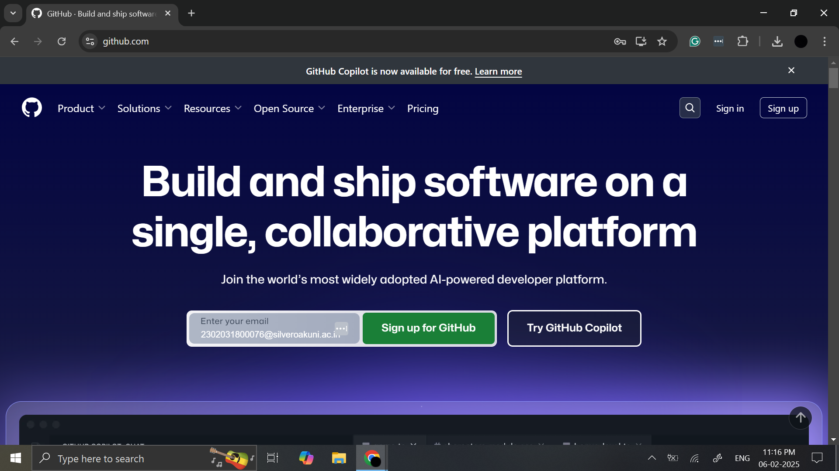

**Step 2) Sign Up:**

* Click on Sign up in the top-right corner.
* Enter your email address and click Continue.
* Follow the prompts to create a username, password, and verify your account via email.

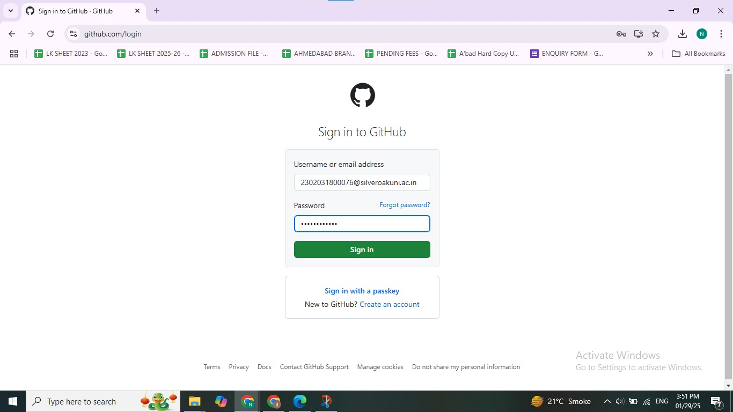

**Step 3) Complete the Setup:**

* After verification, you can choose a plan. For most people, the Free plan is sufficient.
* Finish setting up your account by providing some basic information, such as your interests and usage preferences.

**Creating a New Git Repository**

* Once you're signed in, click on the + icon in the top-right corner and select New repository.

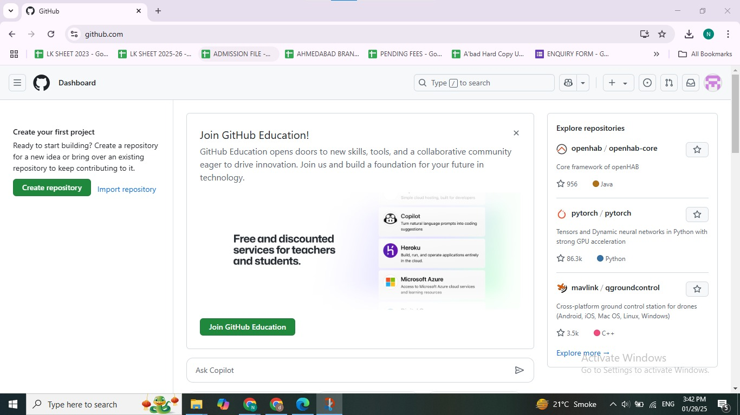

* Fill in the repository details:
* **Repository name:** [**2302031800076**](https://github.com/TheNisarg9/2302031800076)
* **Description:** (optional)
* **Public** or **Private**: Public

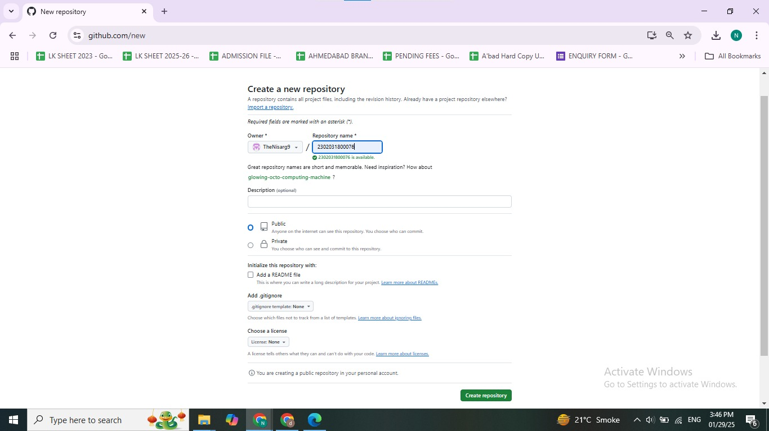

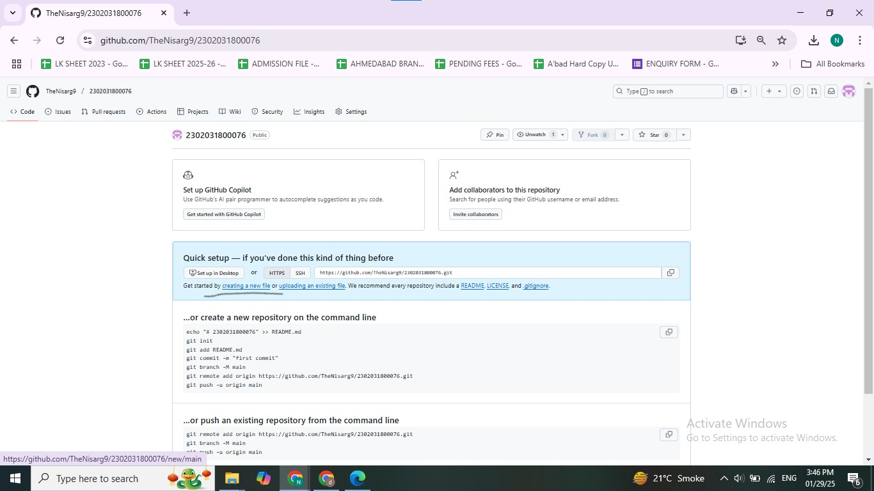

**Adding Two Folders to the Repository**

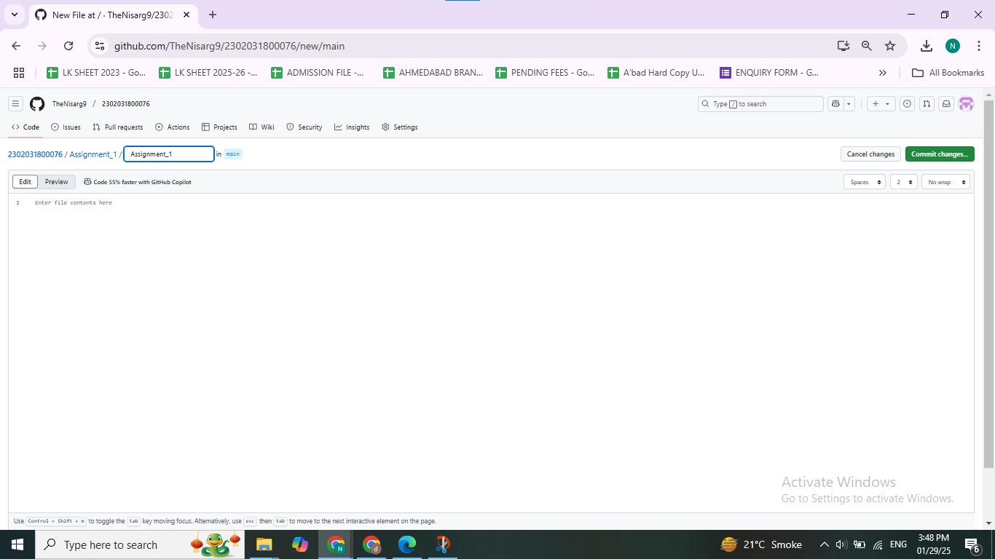

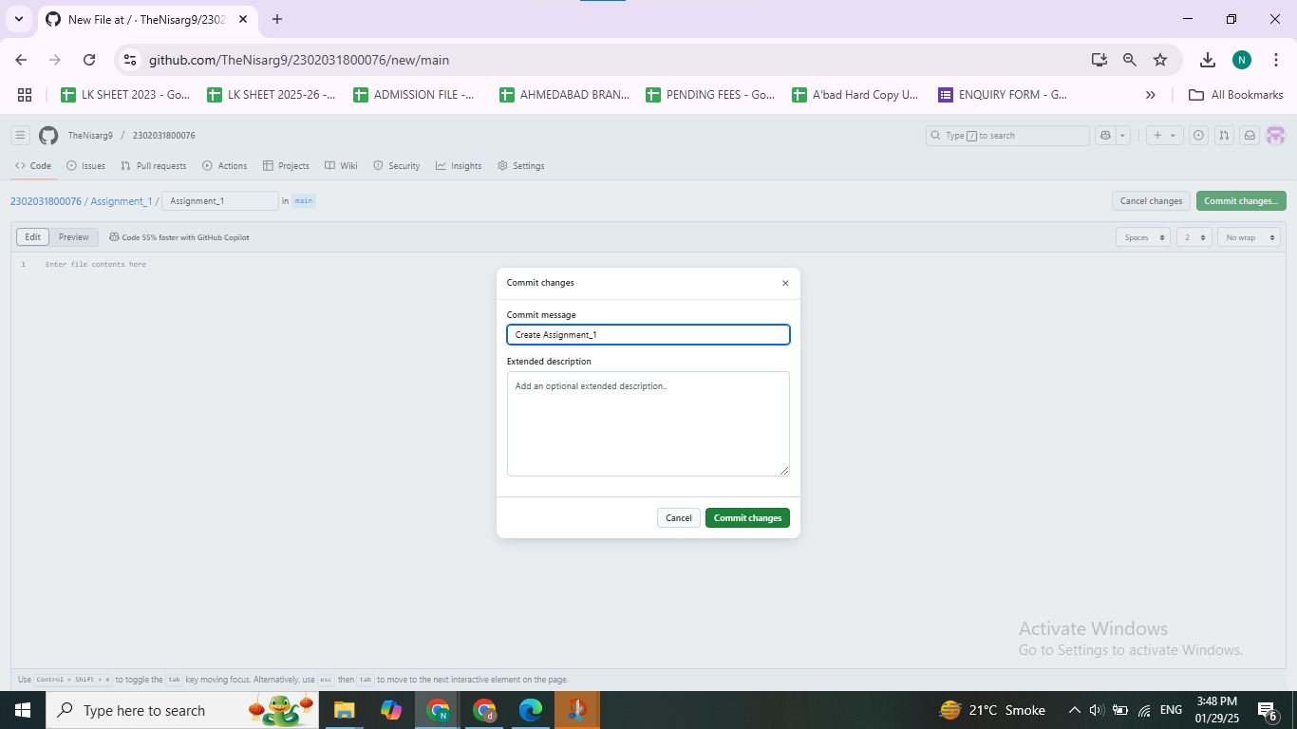

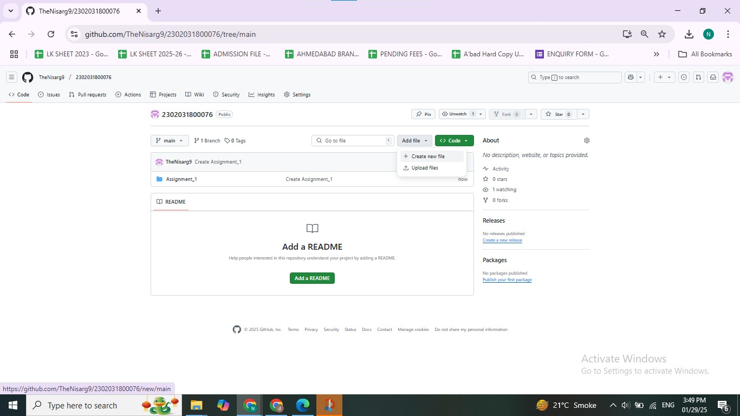

s